LAB 6
- SVM MODEL

# Import required libraries
from sklearn import datasets
from sklearn.model_selection import train_test_split
from sklearn.svm import SVC
from sklearn.metrics import accuracy_score, classification_report, confusion_matrix

# Load dataset
data = datasets.load_breast_cancer()
X = data.data
y = data.target

# ---- Display Dataset Name ----
print("Dataset Used: Breast Cancer Dataset\n")

# Split dataset
X_train, X_test, y_train, y_test = train_test_split(
X, y, test_size=0.2, random_state=42
)

# Create SVM model
svm_model = SVC(kernel='linear', C=1)

# Train model
svm_model.fit(X_train, y_train)

# Predictions
y_pred = svm_model.predict(X_test)

# Evaluation
accuracy = accuracy_score(y_test, y_pred)
conf_matrix = confusion_matrix(y_test, y_pred)
report = classification_report(y_test, y_pred)

# ---- Display Results ----
print("=== SVM MODEL RESULTS ===\n")

print(f"Accuracy: {accuracy:.4f}\n")

print("Confusion Matrix:")
print(conf_matrix)

print("\nClassification Report:")
print(report)

OUTPUT:
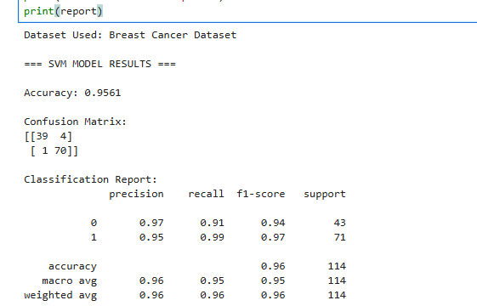

- RANDOM FOREST:

# Import required libraries
from sklearn import datasets
from sklearn.model_selection import train_test_split
from sklearn.ensemble import RandomForestClassifier
from sklearn.metrics import accuracy_score, classification_report, confusion_matrix

# Load dataset
data = datasets.load_breast_cancer()
X = data.data
y = data.target

# Display dataset name
print("Dataset Used: Breast Cancer Dataset\n")

# Split dataset
X_train, X_test, y_train, y_test = train_test_split(
X, y, test_size=0.2, random_state=42
)

# Create Random Forest model
rf_model = RandomForestClassifier(n_estimators=100, random_state=42)

# Train model
rf_model.fit(X_train, y_train)

# Predictions
y_pred = rf_model.predict(X_test)

# Evaluation
accuracy = accuracy_score(y_test, y_pred)
conf_matrix = confusion_matrix(y_test, y_pred)
report = classification_report(y_test, y_pred)

# Display results
print("=== RANDOM FOREST RESULTS ===\n")

print(f"Accuracy: {accuracy:.4f}\n")

print("Confusion Matrix:")
print(conf_matrix)

print("\nClassification Report:")
print(report)

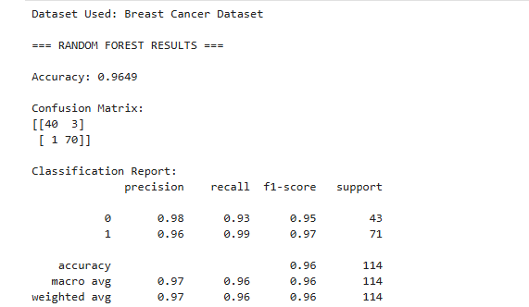

- BOOSTING ENSEMBLE
# Import required libraries
from sklearn import datasets
from sklearn.model_selection import train_test_split
from sklearn.ensemble import AdaBoostClassifier
from sklearn.metrics import accuracy_score, classification_report, confusion_matrix

# Load dataset
data = datasets.load_breast_cancer()
X = data.data
y = data.target

# Display dataset name
print("Dataset Used: Breast Cancer Dataset\n")

# Split dataset
X_train, X_test, y_train, y_test = train_test_split(
X, y, test_size=0.2, random_state=42
)

# Create AdaBoost model (fixed warning by using SAMME)
boost_model = AdaBoostClassifier(
n_estimators=50,
learning_rate=1,
algorithm='SAMME', # avoids FutureWarning
random_state=42
)

# Train model
boost_model.fit(X_train, y_train)

# Predictions
y_pred = boost_model.predict(X_test)

# Evaluation
accuracy = accuracy_score(y_test, y_pred)
conf_matrix = confusion_matrix(y_test, y_pred)
report = classification_report(y_test, y_pred)

# Display results
print("=== BOOSTING (ADABOOST) RESULTS ===\n")

print(f"Accuracy: {accuracy:.4f}\n")

print("Confusion Matrix:")
print(conf_matrix)

print("\nClassification Report:")
print(report)

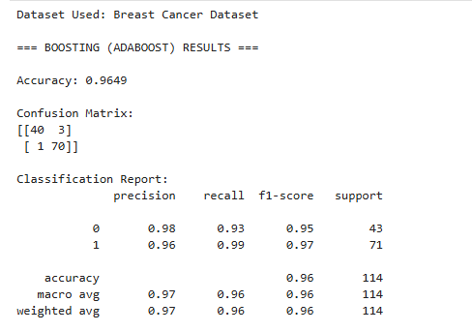
- K MEANS
import pandas as pd
from sklearn.cluster import KMeans
from sklearn.preprocessing import StandardScaler

# Load CSV file
data = pd.read_csv("iris.csv")

# Display dataset name
print("Dataset Used: Iris CSV File\n")

# Select numerical columns
X = data.select_dtypes(include=['int64', 'float64'])

# Feature scaling
scaler = StandardScaler()
X_scaled = scaler.fit_transform(X)

# Create K-Means model
kmeans = KMeans(n_clusters=3, random_state=42)

# Train model
kmeans.fit(X_scaled)

# Predict clusters
clusters = kmeans.predict(X_scaled)

# Add cluster labels to dataset
data['Cluster'] = clusters

# Display results
print("=== K-MEANS CLUSTERING RESULTS ===\n")

print("Cluster Labels (first 10):")
print(clusters[:10])

print("\nCluster Centers:")
print(kmeans.cluster_centers_)
print("\nWCSS (Inertia):")
print(kmeans.inertia_)

print("\nUpdated Dataset (first 5 rows):")
print(data.head())
